
Featherstone News
July 2026
Dates for your diary:
Thursdays– Stay and Play 9:45am – 11am with Maddie at Osborne Nursery 0 -2 year olds
Transition events through July – Please ensure you check emails and letters for visits to your child’s new school.
July 2026 – Visits for new families at Nursery
WC: 7th July2026– Parent/ carer meetings – see Tapestry for details.
Thursday 9th July – Little Learners Celebration Day!
WC: 15th July – Leavers Celebrations! Details to follow, check Tapestry. The Jungle Party for all of out Litte Learners!
Friday 17th July – LAST day of summer term.
Monday 31st August – BANK HOLIDAY
Tuesday 1st September – NURSERY CLOSED FOR STAFF TRAINING
Wednesday 2nd September – Welcoming new children and home visits for our new Little Learners.
SCHOOL FEES:
Please ensure that you have paid your child’s dinner money and your top –up funds by the end of the term.

What a wonderful year we have had! We would like to thank all parents and carers for their support over the year.
Some of our children are starting their new journey in primary school – we will miss you all and we know you will continue to shine! We are all very proud of your achievements.
OFSTED visited our school on Tuesday 30th June and Wednesday 1st July. The official report will be published in September. Thank you to everyone that support us, completed the survey and spoke to the inspectors. We are very proud of our whole community!

Children returning to Nursery School in September 2026
Children returning to Nursery School will come back in to school from Wednesday 2nd
September. You will have a letter confirming your child’s pattern of attendance. We look forward to seeing you in September. Please remember to supply nappies and changes of clothes in a named bag.
Thank you.
Sun Safety:
1.Wear sun cream and keep applying
2.Drink lots of water
3.Spend time out of the sunshine, especially between 11am and 3pm
4.Wear a hat
https://www.bbc.co.uk/cbeebies/watch/sun-safety-for-kids
We would like to wish you a very safe and happy summer break. Good luck to all of the children starting school and we look forward to children returning to nursery and new families too.

Attendance is very important at Nursery. We like to see you for all of your sessions each week. We like families to aim for attendance to be between 95 and 100%. Look out for the Cool Kittens stickers!
Congratulations to Robins and Caterpillars for the best attendance in Nursery in June . FANTASTIC!! Well done to the parents and carers too. Let’s aim for 95% and above in July.


We have achieved the Silver Level of the Rights Respecting Schools Award (RRSA) and as part of this award we work with the children as well as with you to raise awareness about the UN Convention on the Rights of the Child.

Rights Respecting Schools Award (RRSA)
July 7th 2026 is National Thank You Day!
A day to celebrate all the things that keep us connected in our communities, saying ‘thank you’ to each other – We would like to say a big thank you all our children, parents, carers and staff for everyone’s hard work this academic year!



: 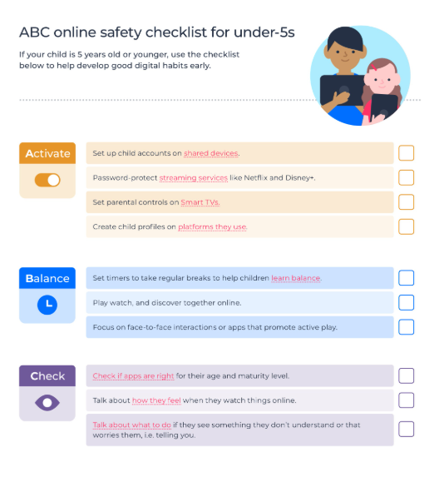

Internet Safety:
Please have a read of the Under 5s On Line Safety Checklist from internetmatters.org . At our setting, we help children begin to understand how to use technology safely and responsibly. Through age-appropriate discussions and activities, children learn that they should always tell a trusted adult if they see something online that worries or upsets them. We encourage all of you at home to promote the safe use of devices and promote the importance of kindness, privacy and asking for help when needed.

Little Learners have been reading ‘ We’re Going on a Bear Hunt by Michale Rosen – they have had lots of lovely experiences to help them learn about the journey in the story.
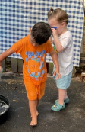
Out trips this year have been great fun and provided fabulous learning opportunities.
Beacon park in Lichfield was a fantastic success – it was sunny and dry, we had a train ride, fed the ducks and geese and then explored the park, some children even went pond dipping!

Little Learners went to Sutton Park – we experienced sunshine, rain, hail and sunshine again! We had such a lovely time feeding the ducks and playing in the park together!
